 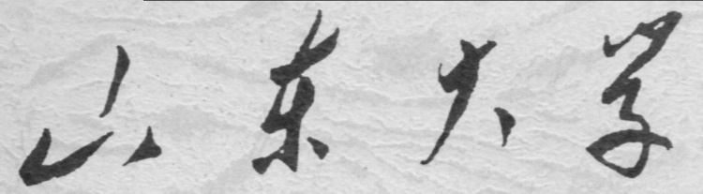

**崇新学堂**

**2022－2023学年第一学期**

实 验 报 告

课程名称： Experiments of Introduction to EECS

实验名称： Homework 3: Head Light

专 业 班 级 崇新21

学 生 姓 名 余昊 葛明烨 崔宇鑫

实 验 时 间 2022年11月09日

**Step1 Design a voltage divider from the photoresistors whose output voltage goes up when the light on the left photoresistor goes up relative to the light on the right.**

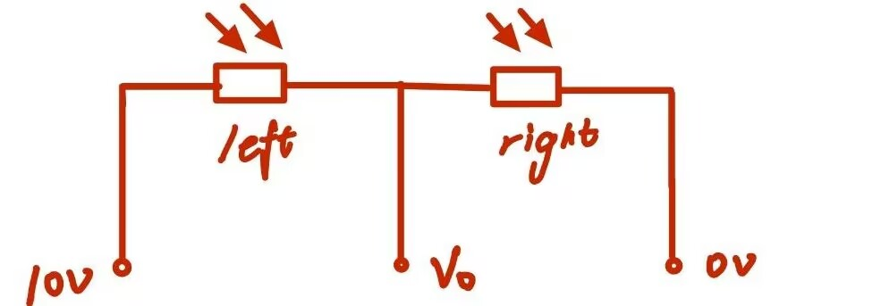

*Because the resistance of the optical appliance is inversely proportional to the light intensity incident on it, when the light on the left optical appliance rises relative to the light on the right, the resistance of the left optical appliance is smaller than that of the right optical appliance, so the partial voltage on the right optical appliance is large, resulting in a large output voltage.*

*Wk.8.4.1*

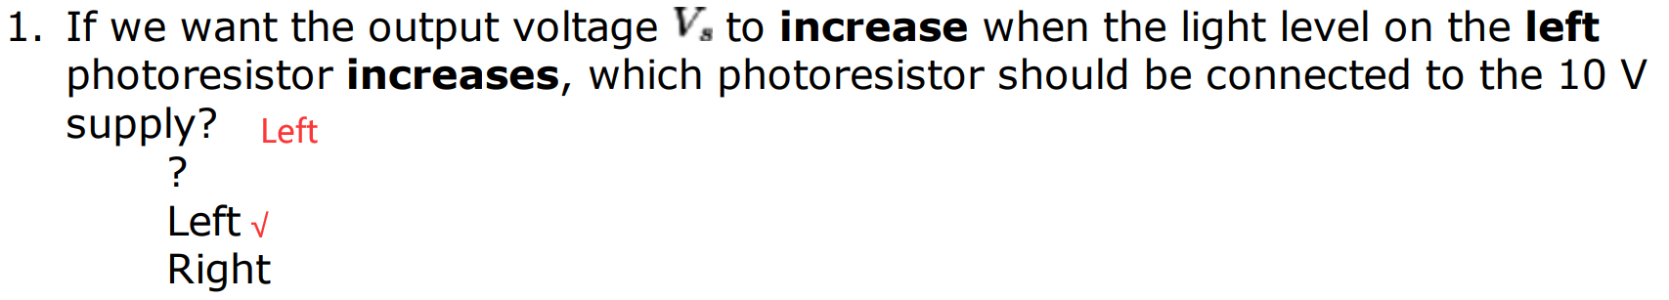

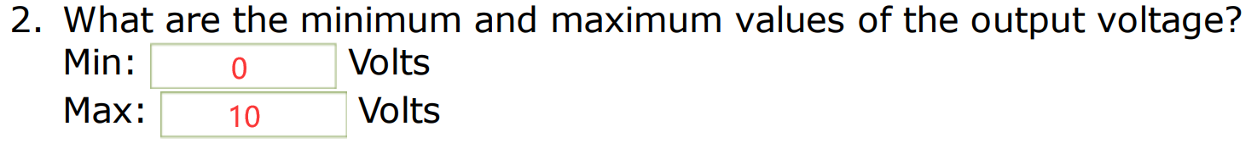



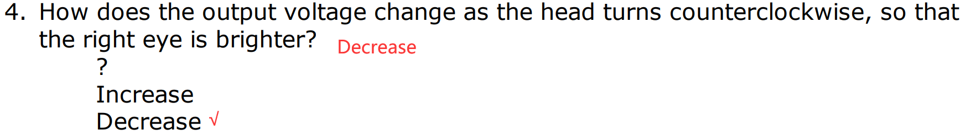

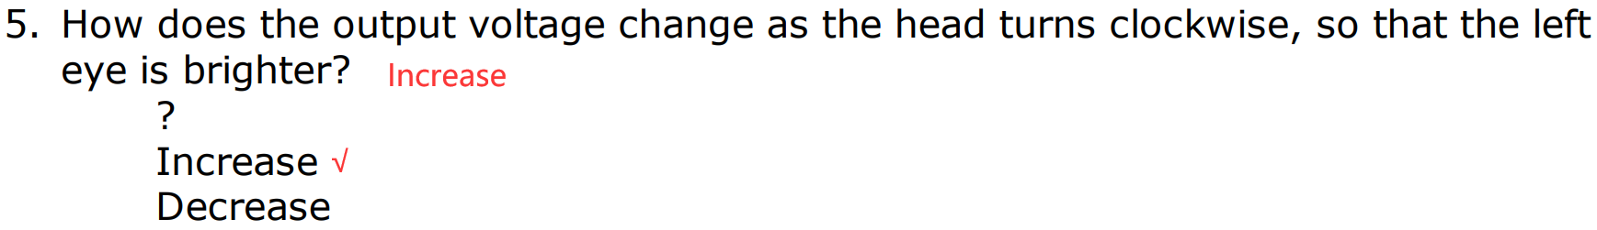

**My circuit diagram:**

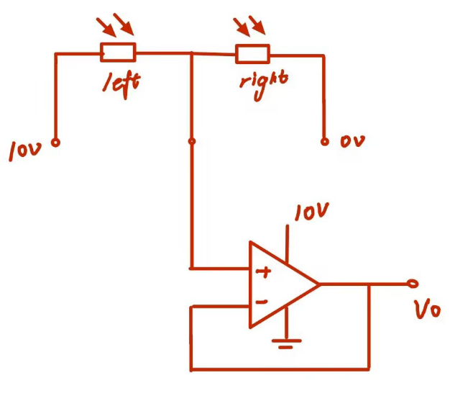

*For the output voltage of the sensor, we connect a buffer circuit at the output port, so that the generated voltage will not be affected by the subsequent circuit.*

**Step2*. Based on what you found about the range of voltages produced by the light sensor, what voltage should the controller output when the head is pointing directly at the light? Can we use a simple inverting or non-inverting amplifier as in the course notes to implement the control circuit? Do the Tutor problem to get an idea of how to tackle this.***

*When the head of the machine is facing the light, the sensor will output a voltage of 5V. However, the speed of the motor should be 0 at this time, so the control of the motor of the robot head cannot be realized by a simple in-phase or inverse-phase amplifying circuit. To enable the motor to rotate in both directions, the other input of the motor is connected to a buffer circuit that bisect the driving voltage. So that when the head is facing the light, our motor input and output voltage difference is 0, the motor does not rotate. The output voltage of the sensor is 0-10V, which can drive the motor to rotate bidirectional under the appropriate gain.*

*Wk.8.4.2*



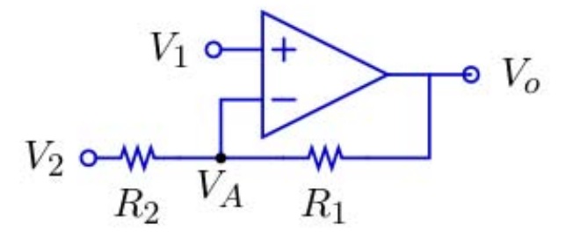

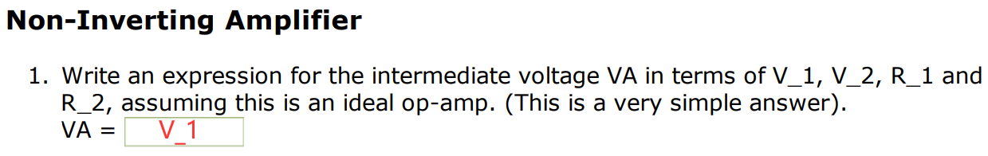

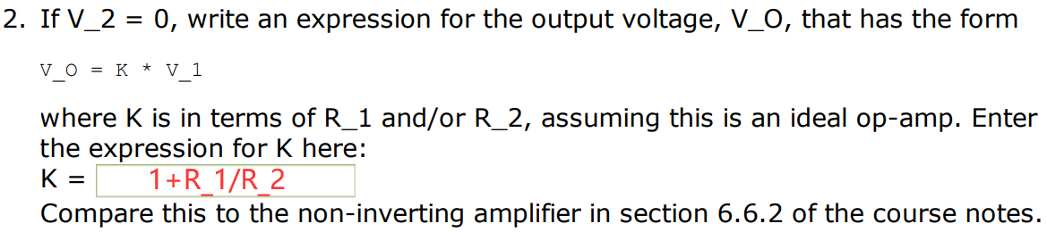

The result is the same as the relevant part of 6.6.2.

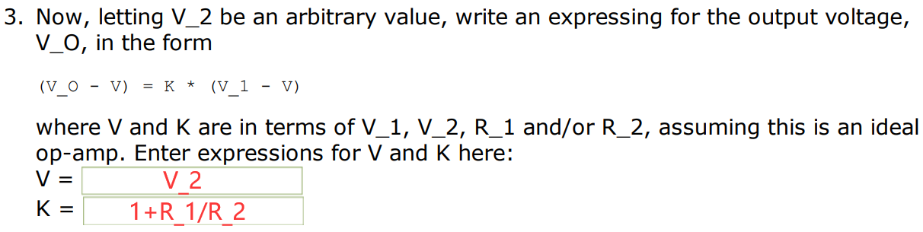

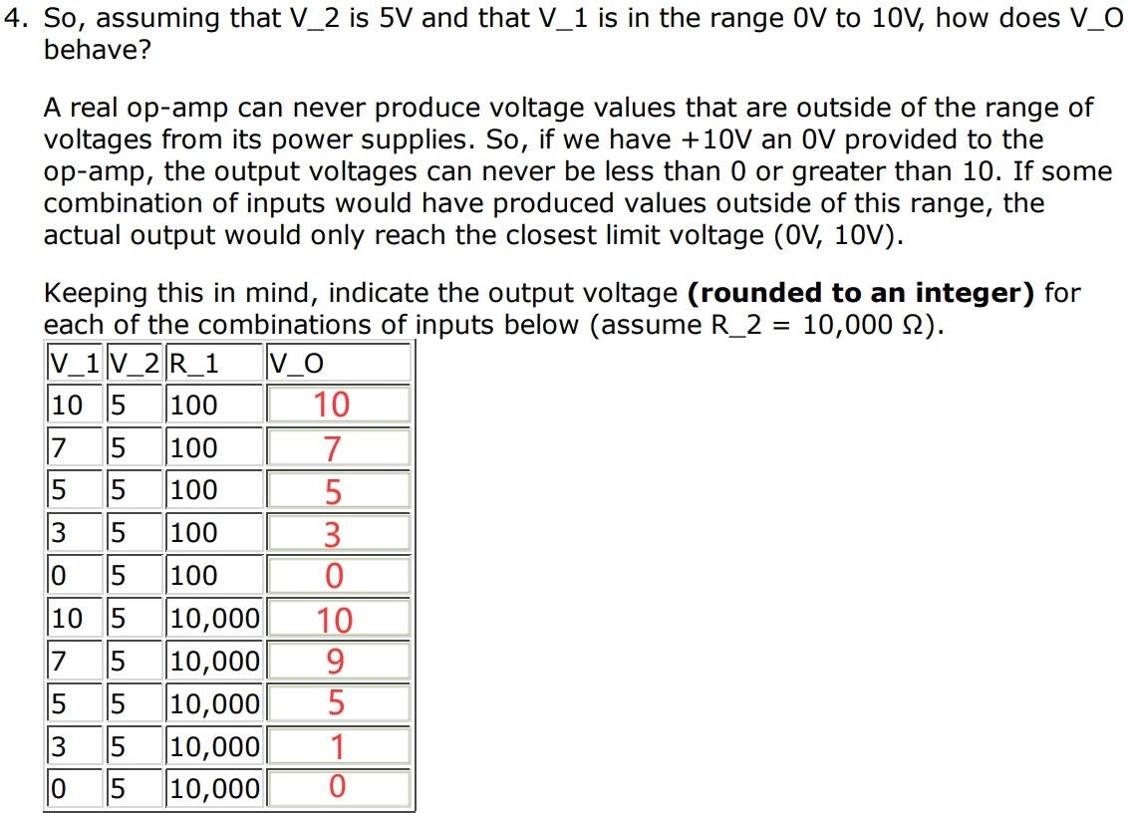

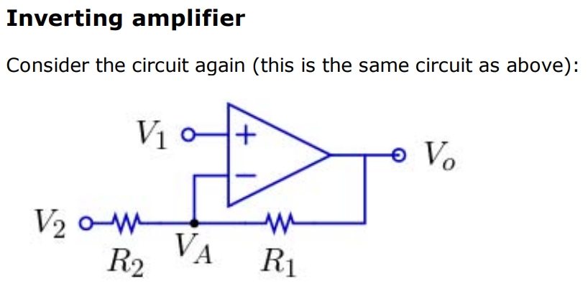

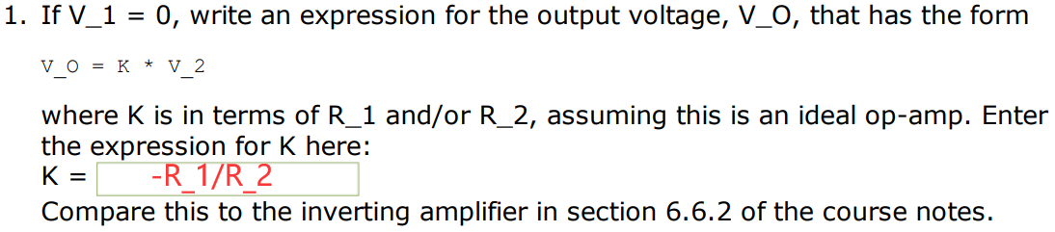

*The result is the same as the relevant part of 6.6.2.*

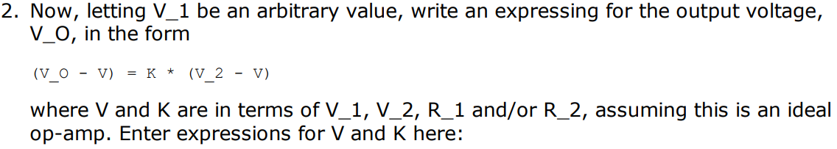



**Step3*. Find best k_c.***

*Wk.8.4.2*

*We use the code in problem 2, adjust the relevant parameters in the code according to the given parameters in Wk.8.4.3, and then get the optimal k_c and corresponding dominant poles under different k_s.*

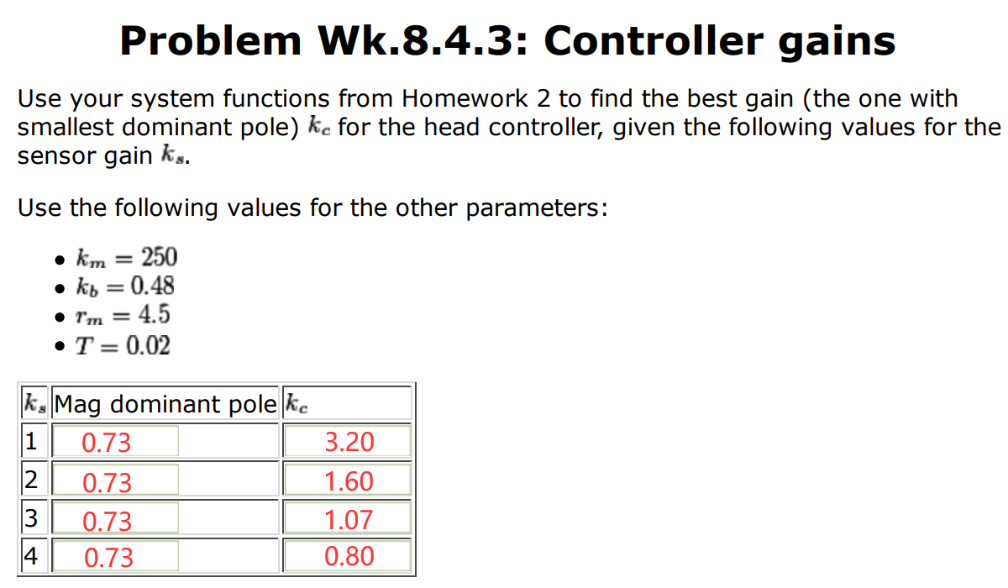

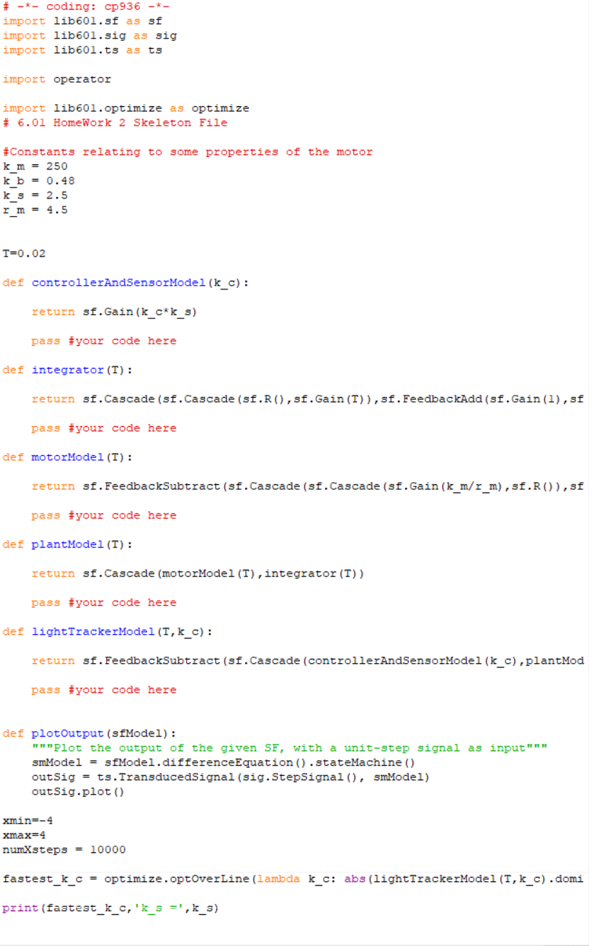

*The code runs as follows:*

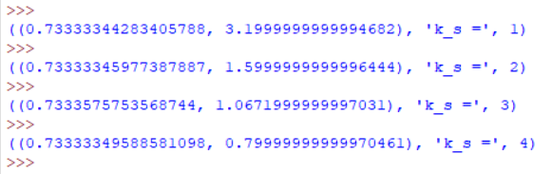

**Step4** ***Design a controller circuit that can handle the range of gains that you might need to implement.***

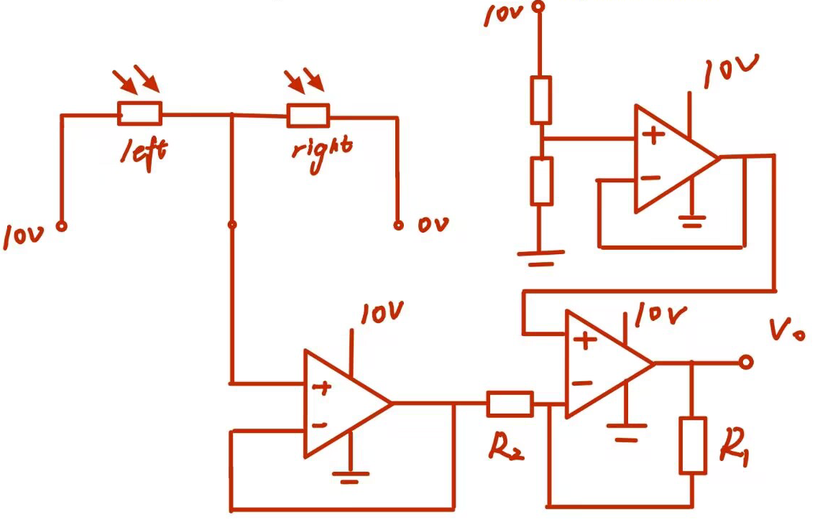

*Since the gain k_c < 1 when k=4, we can only choose an inverting amplifier. We input the output voltage V_s of the head sensor into the negative end of another integrated operational amplifier. If the other end of the integrated operational amplifier is connected to 5V voltage, the following formula can be obtained:*

*The gain is adjusted by adjusting the ratio of R_1 to R_2.*

*k_c=*

**Step5**

***Run both of the eyeServo simulations with gains 0.5, 2, 3 and 5. and save the resulting plots***

***(that’s 8 plots).***

*We set R_2 equal to 2 000Ω and change the resistance of R_1 to change the magnification.*

eyeServo 1

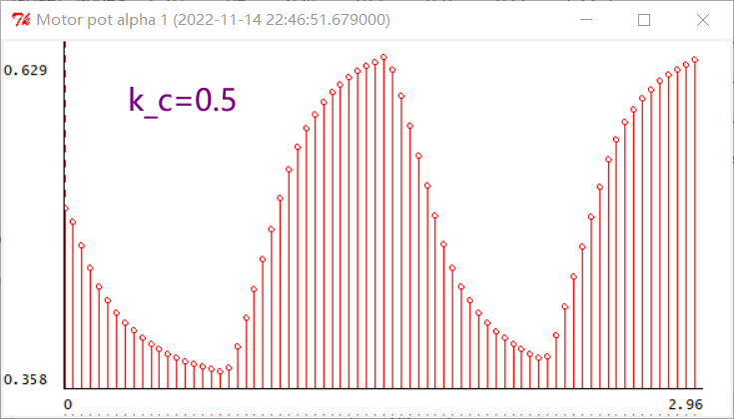

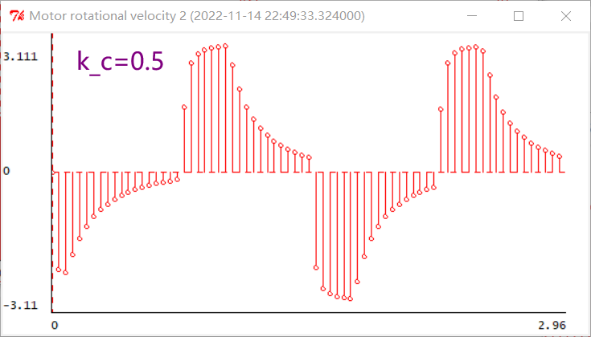

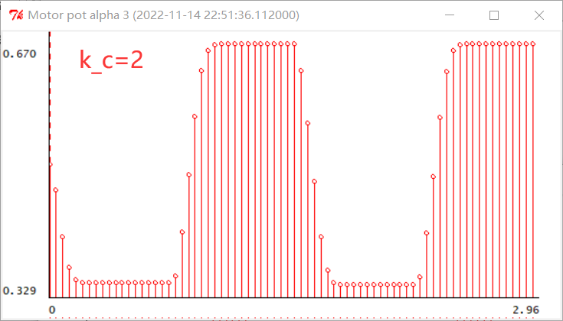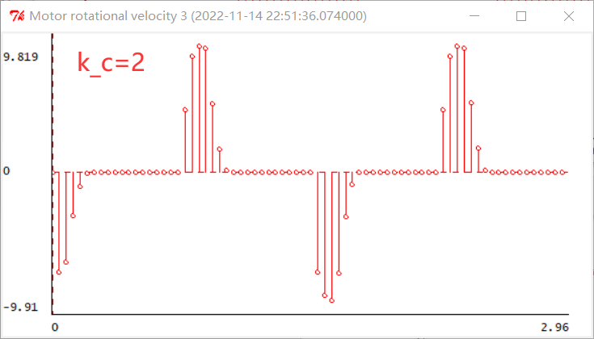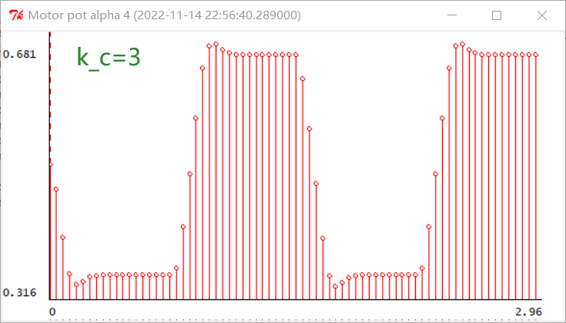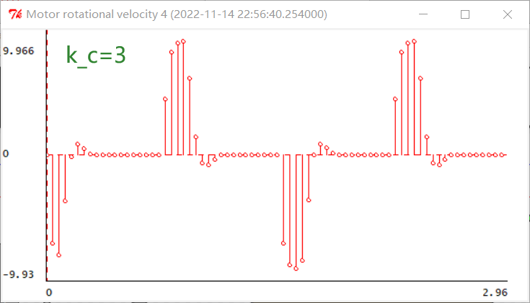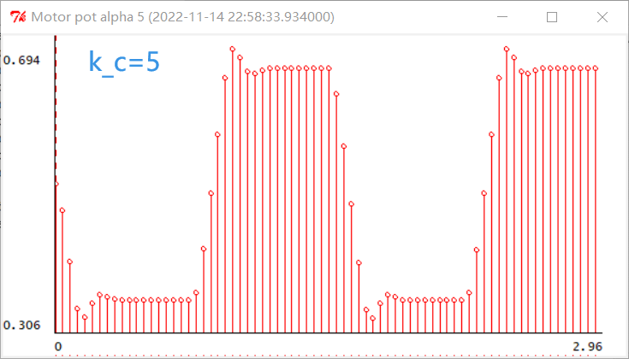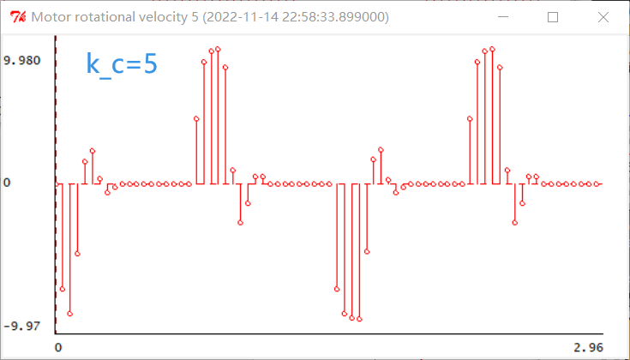

eyeServo 3

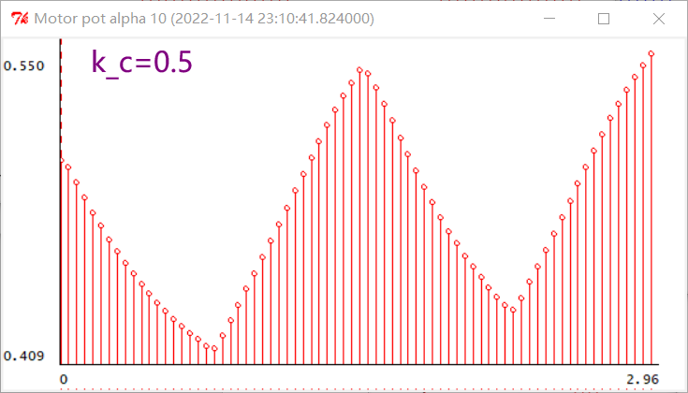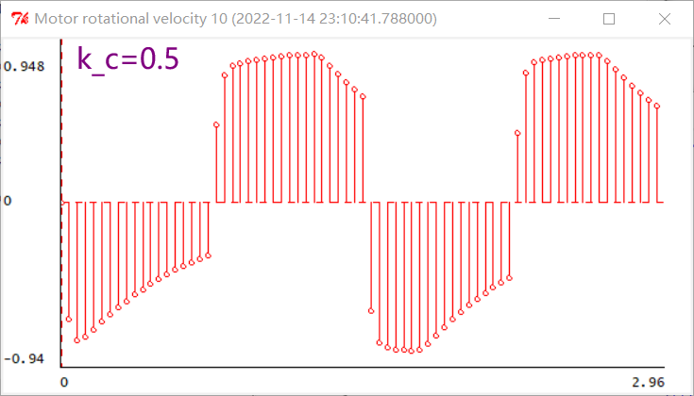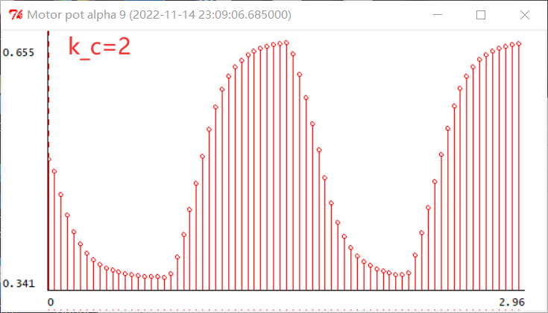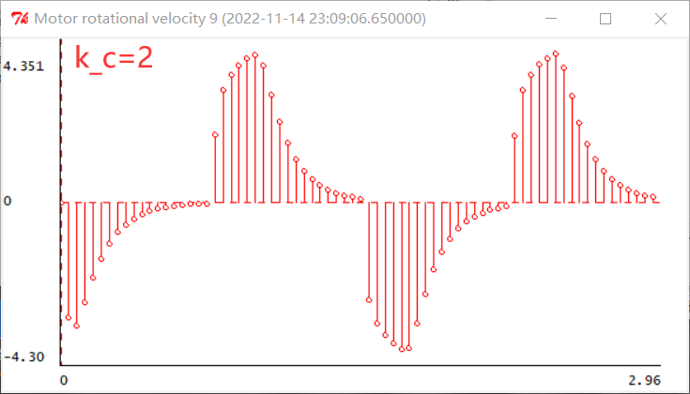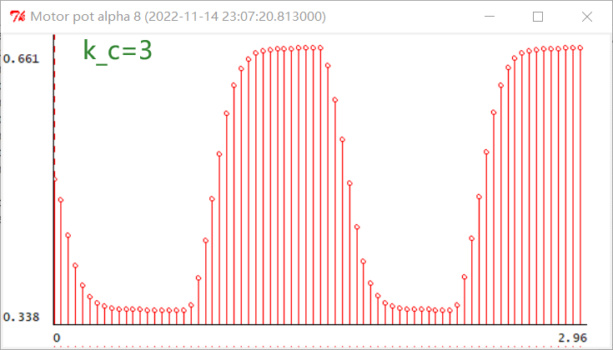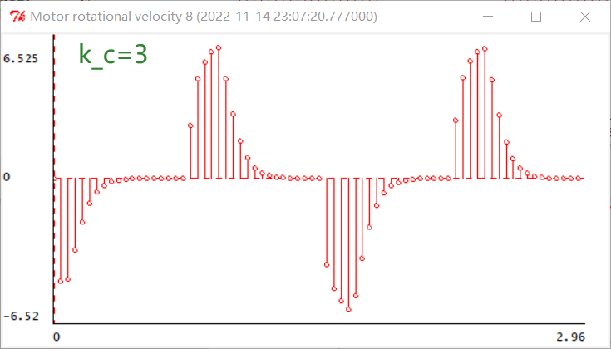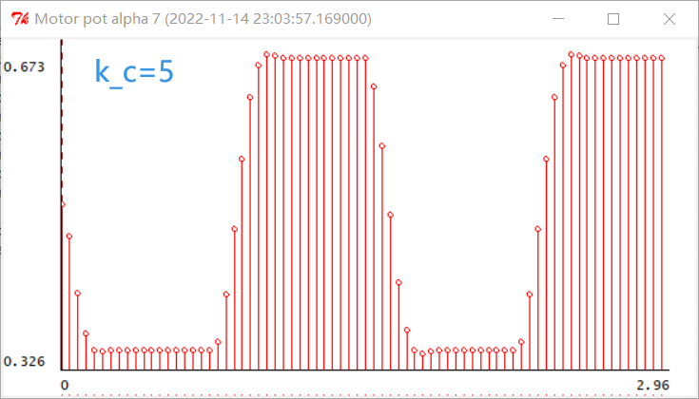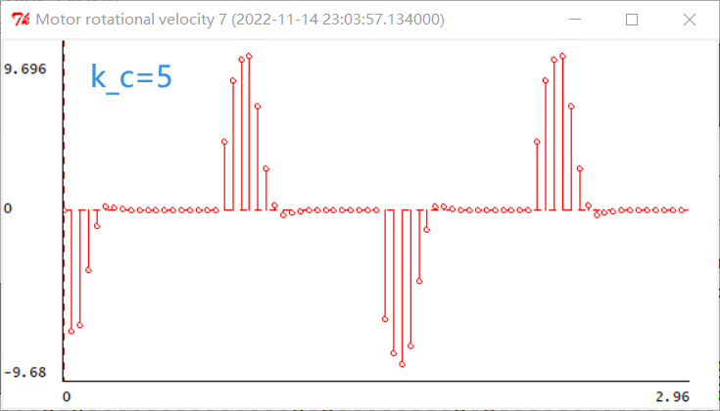

*Wk.8.4.2*

***Circuit diagram***

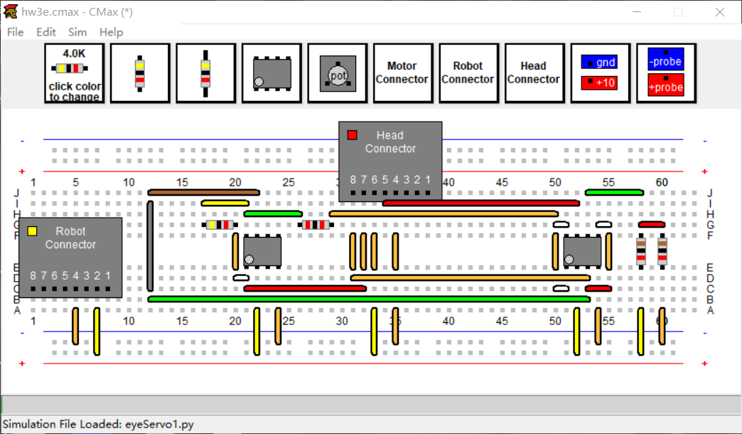

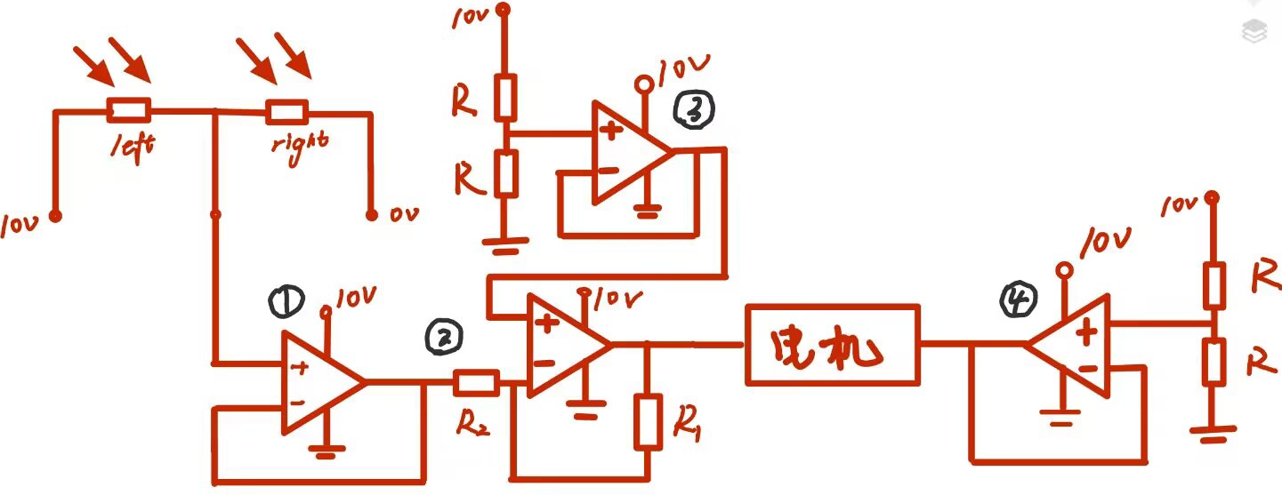

***CMax code***

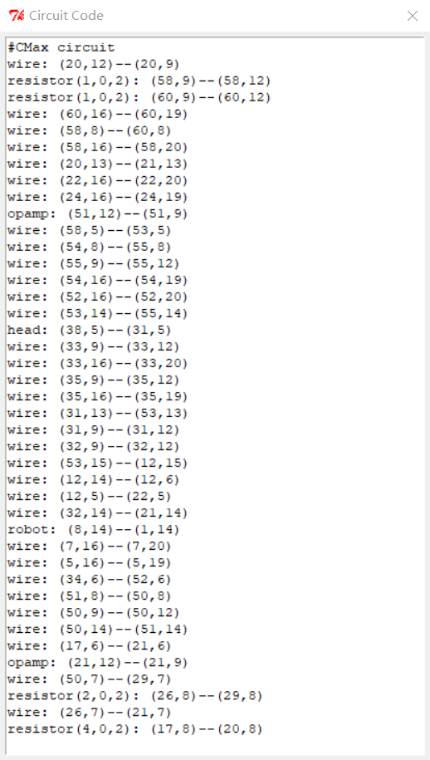

***Discussion***

***Explain the key elements in your design. Does your design include a buffer on the signal from the eyes? Explain why you do or do not need it? How did you implement the gain k_c? Why did you choose that implementation?***

*We need four integrated operational amplifiers in our design. The integrated operational amplifier ① connected to the output end of the optical sensor is used as a buffer circuit to stabilize the output voltage of the optical sensor and prevent the influence of subsequent circuits on the output voltage.*

*Integrated operational amplifier ② receives the output voltage of integrated operational amplifier ① and achieves the gain k_c.*

*Integrated operational amplifier ③ delivers a stable voltage of 5V.*

*Integrated operational amplifier ④ delivers a stable voltage of 5V.*

*Integrated operational amplifiers ①, ③, and ④ are buffers that stabilize the input voltage without interference from subsequent circuits.*

*We can change the gain k_c by changing the resistance of R_1 to change the ratio of R_1 to R_2.* 

*As k_s approaches 4, the ideal magnification of k_c will be less than 1. So we chose a reverse op amp instead of a non-reverse op amp.*

*The output voltage of the integrated operational amplifier 2 needs to be raised because the output voltage is theoretically negative and the actual minimum value is 0. We increase the output voltage by connecting the input to 5V in the same phase.*

***What do the simulations tell you about the circuit's performance, in reference to the design goals described in the HW3 handout?***

*We found that the analog circuits respond about six orders of magnitude faster than the software that the robot&apos;s brain runs, but with a significantly increased level of complexity. Therefore, in the actual engineering design, the two characteristics should be selected according to different objectives.*

**Summary**

*1.We first want to adjust the output voltage of the sensor so that the motor can rotate in both directions by pulling down the output voltage of the sensor. However, this solution was eventually rejected because symmetrical voltages of -10V could not be found in circuits with only 0V and 10V.*

*2. When implementing gain k_c, we first consider the case of connecting the input to the noninverting input. If the value of the optimal gain k_c is always greater than 1, we can directly use a noninverting proportional op amp, which can also reduce the use of integrated op amps. However, in practice, k_c there is a value less than 1, making it impossible to use a noninverting proportional op amp, so an inverting amplifier must be used.*

*3. We found that when the drive voltage of the motor or light sensor is connected in reverse, the motor can only rotate in one direction. Therefore, when connecting to the circuit, special attention should be paid to the phase relationship and change of the output voltage and the driving voltage.*

*4. We should have used four integrated op amps, but since each integrated op amp has two outputs, we optimized the original circuit. The optimization process is as follows:*

*Before optimization：*

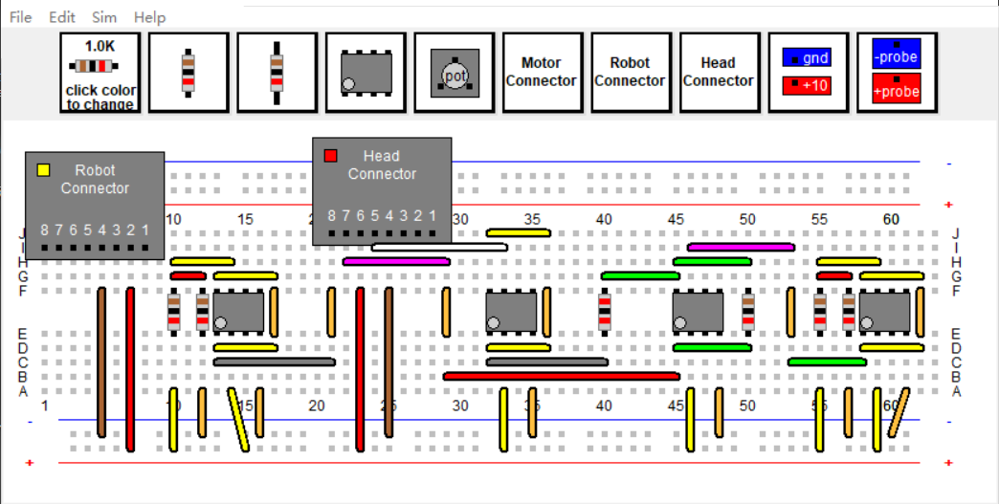

*After optimization：*



*5. Firstly, we compare the variation of motor rotation caused by k_c change when the light intensity and the resistance value of photoresistor are constant. When k_c increases, the rotational acceleration of the motor will increase, so that the motor will rotate at a larger angular speed, so as to reach the target direction faster. However, when k_c is too large, that is, the motor rotation acceleration is too large, the motor will exceed the target direction and oscillate around the target direction for a period of time. Through simulation, we find that when eyeServo1 is loaded for simulation, the optimal value of k_c is around 2. When eyeServo3 is loaded for simulation, the optimal value of k_c is slightly less than 5.*

*Then, we longitudinally compare the simulation results when loading eyeServo1 and eyeServo3 under the same gain k_c. We found that under the same value of k_c, the closer the light intensity is to the optical sensor, the faster the sensor will rotate. Combined with our experimental results in designlab7, it is found that when the light intensity is close to the light sensor, the light sensor will output a larger voltage. Combined with our analysis results in the previous paragraph, we find that the measured value is in agreement with the simulation results. The optimal gain k_c obtained by loading eyeServo1 will be smaller than that obtained by loading eyeServo3.*

*6. Analysis of differences between system functions and actual circuits.*

*When we use the code in homework2 to solve for the optimal gain of k_c at k=2.5, we get the optimal gain of the system function as 1.28. However, the experimental effect obtained by adjusting k_c to 1.28 in CMax is as follows (R_2=100kΩ, R_1=128kΩ, load eyeServo1.py) :*

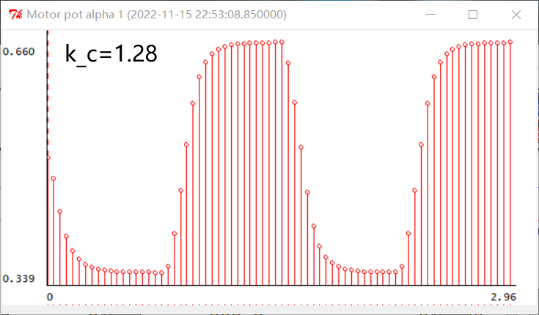

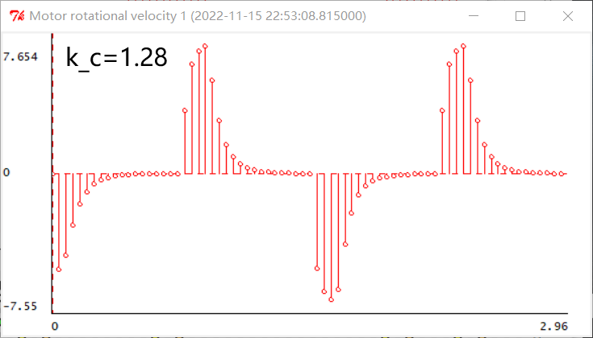

*Comparing the results when eyeServo1 is loaded and k_c=2, we find that when the optimal gain is analyzed using the previous system functions, the best gain we get is not the best gain obtained by actually running the CMax simulation. Why is that? In fact, in the previous system functions, the value of the V_c can be negative, which means that we can directly use the positive and negative of the V_c to determine the turn of the head. However, in the CMax simulation, we used a reverse proportional amplifier to achieve a gain k_c less than 1, but there was no negative voltage in the output value. When we solve this problem, we connect a voltage of 5V at the noninverting input to make the output voltage be raised, so that the voltage of 5V at the other end of the motor is different to achieve the purpose of controlling the direction. However, because of the introduction of a voltage of 5V, the V_c of the output and the input V_s is not a simple*

*relationship, but a*

*relationship.*

*Therefore, the k_c obtained using the system functions in homework2 is not directly equivalent to the k_c when using CMax simulation.*